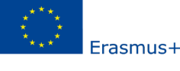
WORK PLAN
DATE | PROGRAM
Day – 1

Day – 2

Day – 3

Day – 4

Day – 5

Name of the participant :
Signature:
Approval of Home Institution Approval of Host Institution

SEMRA SADIK KRUPKA Name:
Erasmus Institutional Coordinator Title:

Date: …./……/20.. Date: …./……/20..

Signature: Signature:
Stamp Stamp

* Staff Mobility in the following fields can qualify as the Digital Opportunity Staff Mobility: development of apps, software, scripts, websites, installation, maintenance and management of IT systems and networks, data analytics, cybersecurity, cloud, quantum/artificial intelligence, encryption, block chain, data mining, privacy and visualisation, programming language, Search Engine Optimisation (SEO), digital marketing, specific software apps for work, Customer Care Management.

